Project Design Phase | Problem – Solution Fit Template
Date | 28 September 2026
Team ID | 6ab2210011b716a3e52c62c6
Project Name | Streamlining IT Procurement: Automatic Standard Laptop Orders With Flow Designer

Filled Canvas:

- Customer Segment(s)  - New hires needing a standard laptop.  - Employees needing replacement/repair.  - Managers approving requests.  - IT Procurement / Asset team. | - Jobs-to-be-Done / Problems  - Employee: get a working laptop fast.  - Manager: approve quickly, no email chase.  - IT: process, order & track without manual re-entry.
- Triggers  - New hire onboarding.  - Laptop damaged/lost/EOL.  - Team expansion or upgrade request. | - Emotions: Before / After  - Before: frustration, unclear status, onboarding delay.  - After: confidence, transparency, trust in IT.
- Available Solutions  - Manual email/phone request to helpdesk.  - Spreadsheet tracking; generic ticket, no automation. | - Customer Constraints  - Manager approval required by policy.  - Limited IT staff; vendor lead time/budget cycles.  - Must keep a standard configuration.
- Behaviour  - Employee emails/calls IT.  - IT manually checks stock & emails manager.  - IT manually raises PO, follows up by phone. | - Problem Root Cause  - No workflow links request → approval → procurement.  - Manual hand-offs cause delay & inconsistent configs.  - No dashboard for real-time status.
- Your Solution  - Automated Flow Designer workflow: employee submits via Service Catalog → auto-routes for manager approval → auto-checks stock → auto-creates fulfilment task or vendor PO → sends status notifications → live dashboard tracks it end-to-end. | - Channels of Behaviour  - Online: Service Catalog portal, email/app notifications, manager approval, dashboard.  - Offline: IT helpdesk walk-in, physical laptop handover.
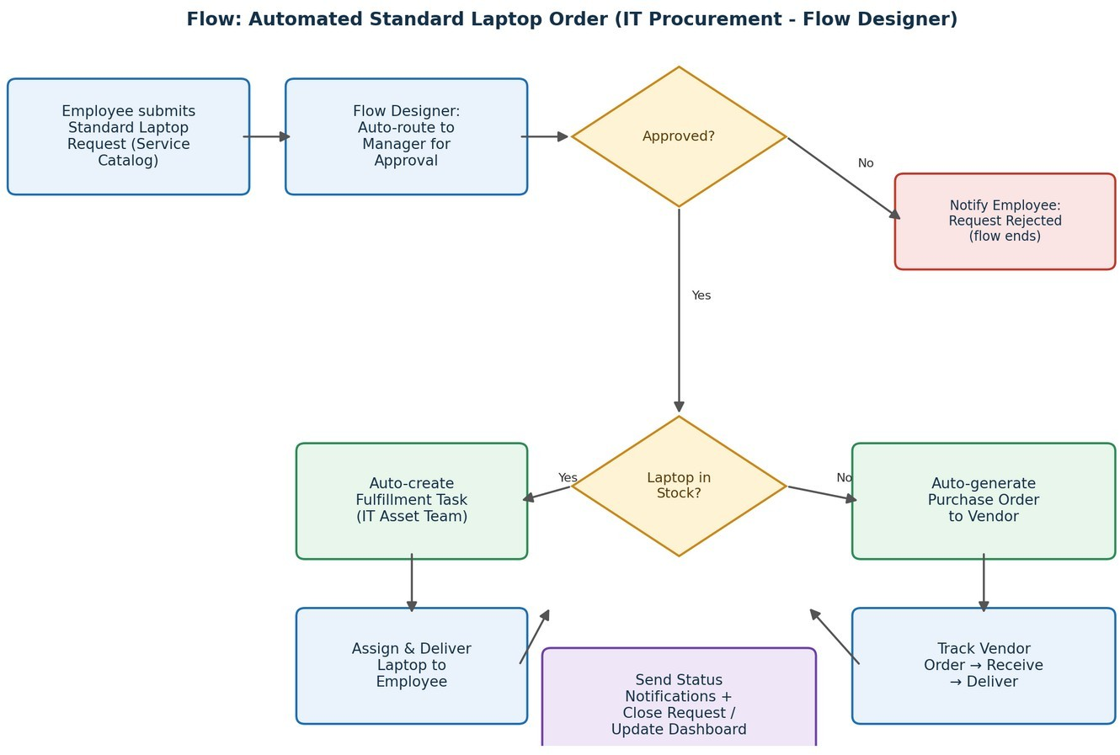
References: 1. https://www.ideahackers.network/problem-solution-fit-canvas/ 2. https://medium.com/@epicantus/problem-solution-fit-canvas-aa3dd59cb4fe

